PSG COLLEGE OF TECHNOLOGY, COIMBATORE -4
DEPARTMENT OF APPLIED MATHEMATICS AND COMPUTATIONAL SCIENCES
III M.Sc Data Science - 5th SEMESTER
15XD56 - JAVA PROGRAMMING LAB
PROBLEM SHEET – 7

https://docs.oracle.com/javase/7/docs/technotes/guides/collections/reference.html

To understand the objective of generic programming and implement generic classes and methods
Java Generic Classes
The Java collections framework (JCF) is a set of classes and interfaces that implement commonly reusable collection data structures. Although referred to as a framework, it works in a manner of a library. The JCF provides both interfaces that define various collections and classes that implement them.
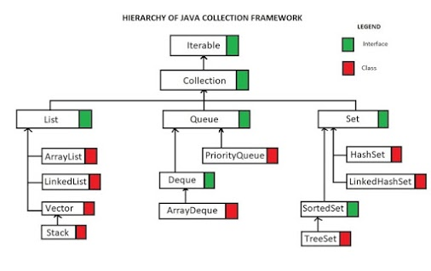
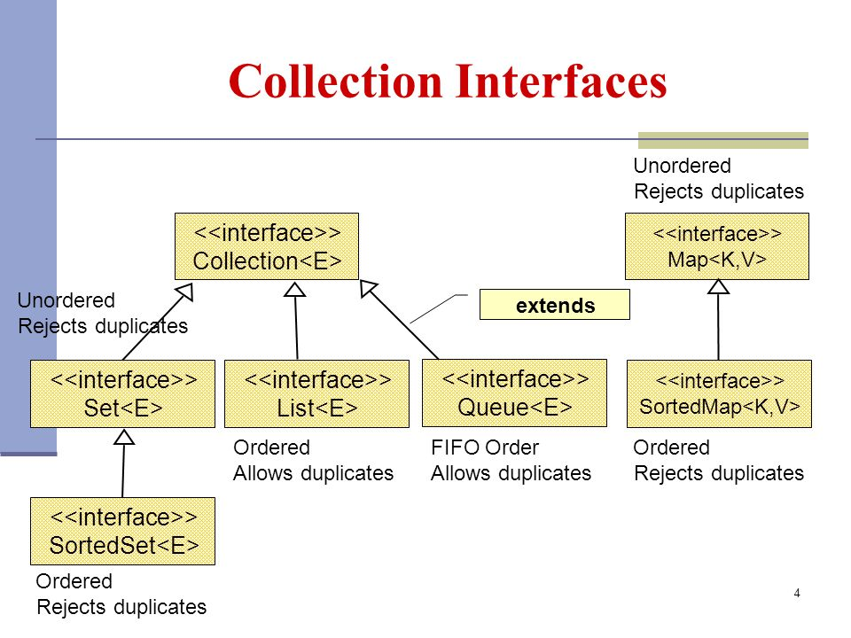

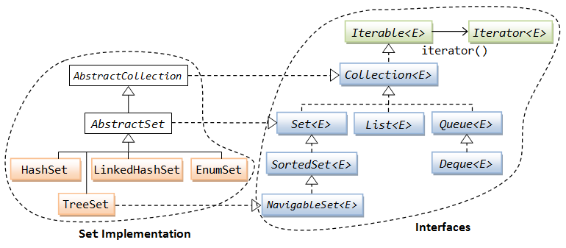

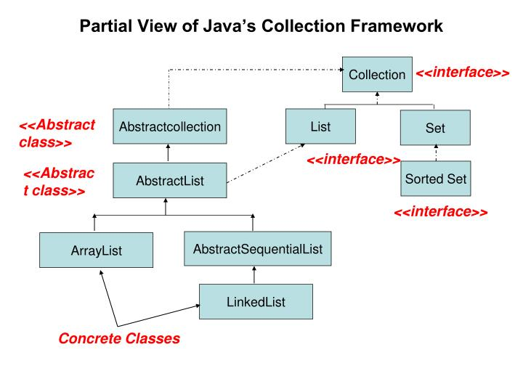
        - A priority queue maintains a list of pairs, each consisting of a priority (an integer) and a name (a String), sorted into increasing order of priority. Three operations are required — one that just creates an empty queue, and then one called insert that takes an integer and a string as its arguments and places them in the correct position in the list. Finally a method next takes no arguments. It removes the first pair from the list and returns its text string. It should throw an exception if the queue is empty when it is called. Give the definition of a Java class that implements the queue object.
        - Define a class that would be capable of representing simple linked lists, where each list-node contains a string. You should show how to traverse such lists, build them and how to reverse a list. In the case of the list reversing code please provide two versions, one of which creates the reversed list by changing pointers in the input list, and another which leaves the original list undamaged and allocates fresh space for the reversed version .
        - Create your own HashSet object Add the following objects with properly initialized values to the newly created HashSet object

2 String objects

2 MyOwnClass object (You will have to create MyOwnClass.java first)

MyOwnClass class has name (String type) and age (int type)

3 Integer ojbects

Create Iterator object from the HashSet object and iterate them to get displayed. Repeat the above for LinkedHashSet, ArrayList
        - Create a List containing set of String objects. Perform the following i) sort ii) shuffle iii) data manipulation
        - Implement a proper generic class for binary trees. You need to provide support for inserting comparable data items into the trees and for printing trees. There should be three methods for printing a tree: one method should print a tree using an in-order traversal, one should print a tree using a pre-order traversal, and one should print a tree using a post-order traversal. Implement an instance method for inserting items into a tree.
        - Define your own generic class Box that can store one object of any type, using generics. Here's the way we imagine using the Box class:
Box<String> b1 = new Box<String>();
b1.putItem("abc");

Box<Point> b2 = new Box<Point>();
b2.putItem(new Point(1, 2));

String s = b1.getItem();
Point p = b2.getItem();
Notice that we can put and get String objects from a Box<String> object, or we could put and get Point objects from a Box<Point> object.
public class Box<T> {

// instance variable declaration
private T item;

// put an item in the box
public void putItem(T item) {
this.item = item;
}

// get the item from the box
public T getItem() {
return item;
}
}

